



Logistic Regression

LAB MANUAL

Disclaimer: The content is curated from online/offline resources and used for educational purpose only
Predicting Diabetes in Indian Patients Using Logistic Regression

Objective:
To build a machine learning model using Logistic Regression to predict whether a patient has diabetes based on medical predictor variables from the Pima Indians Diabetes dataset.
Problem Statement:
Diabetes is a major health concern in India, and early diagnosis can significantly improve patient outcomes. The goal of this lab is to develop a logistic regression model that can predict whether a patient is diabetic or not, using the Pima Indians Diabetes dataset. The dataset includes various medical predictor variables such as glucose level, BMI, age, and insulin levels. By training a binary classification model, we aim to identify the likelihood of a patient being diabetic based on these health indicators. The performance of the model will be evaluated using appropriate classification metrics such as accuracy, precision, recall, and F1-score.

Equipment Required:
- Python installed with Jupyter Notebook / VS Code / Google Colab
- Libraries: pandas, numpy, matplotlib, seaborn, scikit-learn
- Dataset: Pima Indians Diabetes dataset (commonly available in .csv format), containing features such as Pregnancies, Glucose, BloodPressure, SkinThickness, Insulin, BMI, DiabetesPedigreeFunction, Age, and the target variable Outcome (0 or 1)

Prerequisites:
- Basic knowledge of Python
- Understanding of Logistic Regression
- Familiarity with Pandas, NumPy, Matplotlib, and Scikit-Learn libraries

Dataset Description:
- The dataset consists of medical diagnostic measurements for Pima Indian women aged at least 21 years. The dataset includes the following features:
- Pregnancies – Number of times the patient has been pregnant.
- Glucose – Plasma glucose concentration.
- BloodPressure – Diastolic blood pressure (mm Hg).
- SkinThickness – Triceps skinfold thickness (mm).
- Insulin – 2-Hour serum insulin (mu U/ml).
- BMI – Body mass index (weight in kg/(height in m)^2).
- DiabetesPedigreeFunction – Diabetes pedigree function score.
- Age – Age of the patient in years.
- Outcome – Target variable (1 = Diabetes, 0 = No Diabetes).

Procedure:
Step 1: Import Necessary Libraries
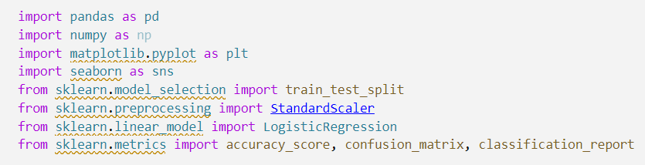

Step 2: Load and Explore the Dataset
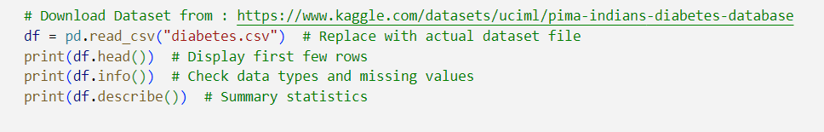

Step 3: Data Preprocessing
- Check for missing values.
- Standardize numerical features.
- Split the dataset into training and testing sets.

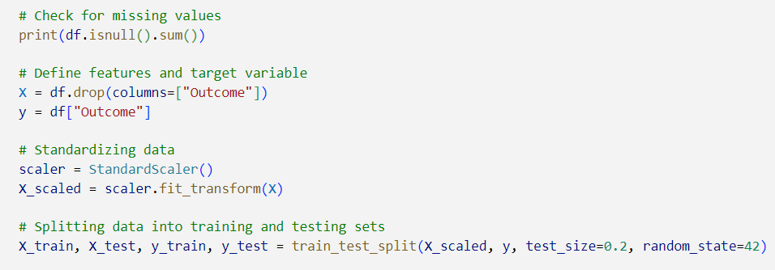

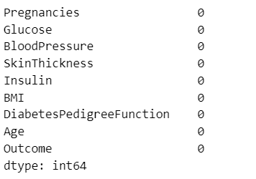

Step 4: Train Logistic Regression Model
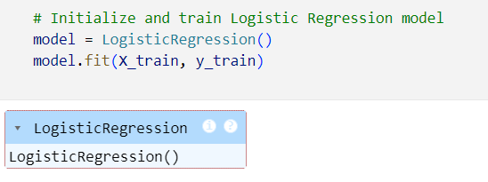

Step 5: Model Evaluation
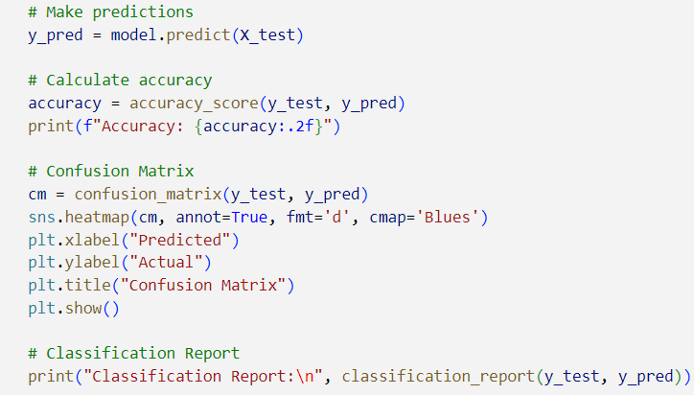
Output:
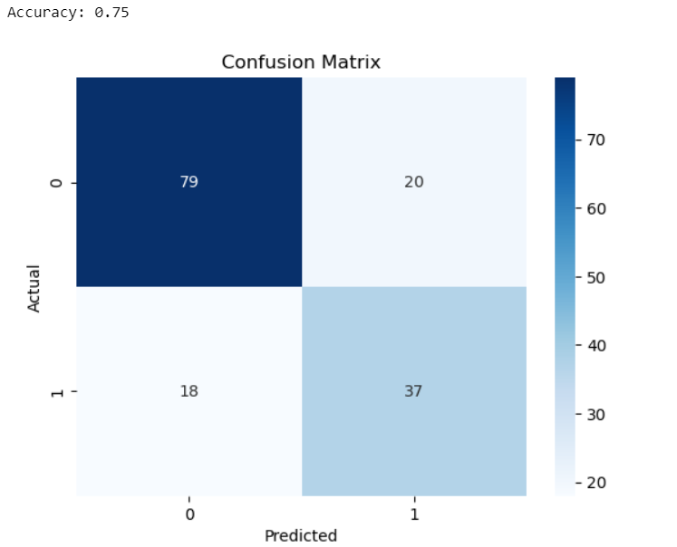
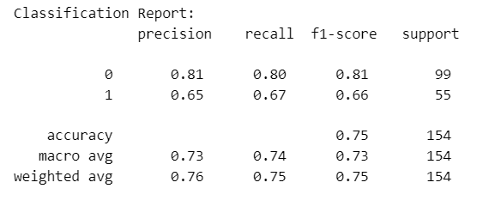
Conclusion
Analyze model accuracy and performance metrics.
Discuss the significance of Logistic Regression in medical diagnostics.
Suggest improvements such as hyperparameter tuning or alternative models.

